Manhattan norm

Alias

Manhatten norm

Taxicab norm

Intro

It is called taxicab norm related to distance that a taxi has to drive from a place to other place in a rectangular street grid.

Def

The taxicab norm is evaluated by summation from 1 to n applying absolute value of $$x_{i}$$ for all elements of vector $$x$$.

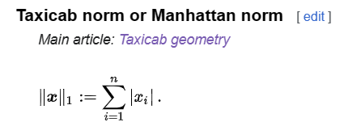

Mistake

$$sigma\left(x_{i},i=1,i=n\right)$$ is NOT a norm, it does NOT satisfy the postive-value property as it may be evaluated to negative.

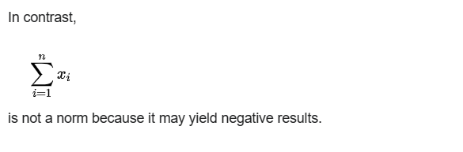

Ref

See Manhatten norm subsection in Examples section in Wiki,

[Norm (mathematics) - Wikipedia](https://en.wikipedia.org/wiki/Norm_(mathematics)#Equivalent_norms)

For more detailed explanation, see Wiki

[Taxicab geometry - Wikipedia](https://en.wikipedia.org/wiki/Taxicab_geometry)